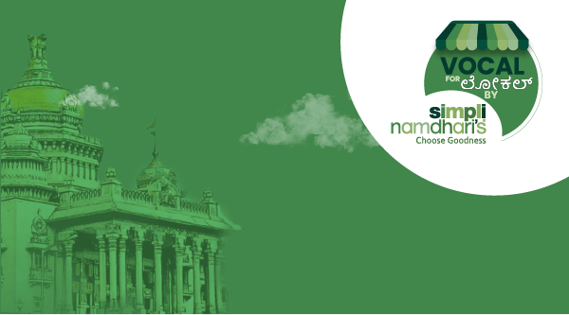**NOMINATION**

**FORM**

**1. Business Overview**

Name of the Brand/Business:______________________________________________________________

Business Registration Number (if applicable):_________________________________________________

Year of Establishment:___________________________________________________________________

Headquarters Location (Only Karnataka-based businesses are eligible):____________________________

**2. Founder Details**

Name(s) of the Founder(s):

Brief Bio of the Founder(s) (including professional background):

Is the business bootstrapped? (Yes/No)

**3. Product Information**

Describe the product(s) you offer:

What makes your product innovative or a first in its category? (Explain how it stands out in the market):

How does your product contribute to a healthier, more sustainable lifestyle? (Optional)

**4. Current Market Presence**

How is your product currently being sold in the market? (e.g., online, retail stores, local markets, etc.)

Please list any current retail partners or e-commerce platforms where your product is available:

**5. Alignment with Simpli Namdhari’s**

Why do you think your product(s) should be considered for listing at Simpli Namdhari’s?

How does your brand align with Simpli Namdhari’s values and target customer base (e.g., fresh, natural, sustainable, local)?

**6. Market and Customer Base**

What is your current target market?

How has your product been received by customers so far (include feedback or testimonials if available)?

**7. Supporting Media**

Upload a short video pitch (1-2 minutes) from the founder explaining the vision behind the brand and why it should be selected:

Upload any product video(s) available (Optional):

**8. Additional Information**

Any awards, certifications, or recognitions your brand has received:

Do you have a website or social media handles? (Please provide links)

